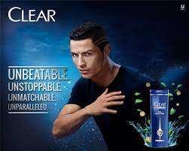

Rhetor: Cristiano Ronaldo, the brand called Clear shampoo and conditioner.

Message: As we all know CR7 is a well-known professional football player, and he is admired, followed and a talented person. And he is endorsing the product by saying ‘’ it overcomes dandruff and feel the intense cooling power of menthol. So, they’re stating that if a famous person like Ronaldo uses it the product is good.

Audience: football fans, anyone who wants a good hair product.

Purpose: Its to promote the product by using a well-known famous player, the audience will really connect to it because people tend to use a product if a famous personality is endorsing it.

Genre/mode: advertisement (using the famous player Ronaldo to get people’s attention)

Mode: Visual (there is a blue-black background) , Gestural(his using his hands to go through his hair) Catchy phrase ( words on the image : unbeatable, unstoppable, unmatchable, unparalleled)

Context: Most men struggle with dandruff. There are a lot of products in the market that claim to clear dandruff. The ad shows their product’s uniqueness by having a football player (whose job causes a lot of sweating and therefore dandruff) endorse it.